ICP 14

**Notification, Calendar and Publishing apps**

ICP Group 4

Name: Sailaja Narra

Email: [sntnn@umsystem.edu](mailto:sntnn@umsystem.edu)

ICP Report:

<https://drive.google.com/file/d/1t4jtiJon8vXPGM0c9mI6Ij61l4y2JvPB/view?usp=sharing>

ICP Video:

<https://umsystem.hosted.panopto.com/Panopto/Pages/Viewer.aspx?id=8527df04-e4af-4245-befb-adfc0009ecbf>

GitHub (Sourcecode):

<https://github.com/UMKC-APL-WebMobileProgramming/ICP14-sailajanarra/tree/main/Source>

My Partner

• Partner: Venkata Mahesh Mokkapati

• Email: [vmzwn@umsystem.edu](mailto:vmzwn@umsystem.edu)

• Repo: <https://github.com/UMKC-APL-WebMobileProgramming/ICP14-Mahesh68>

**Task:**

1. **Notification Event**

This is the main activity code for this notification event

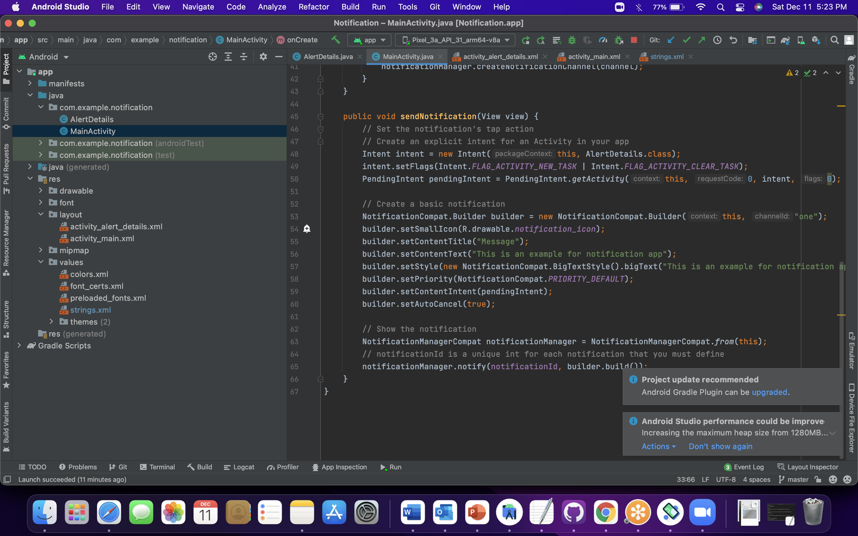

Basic notification setting configuration

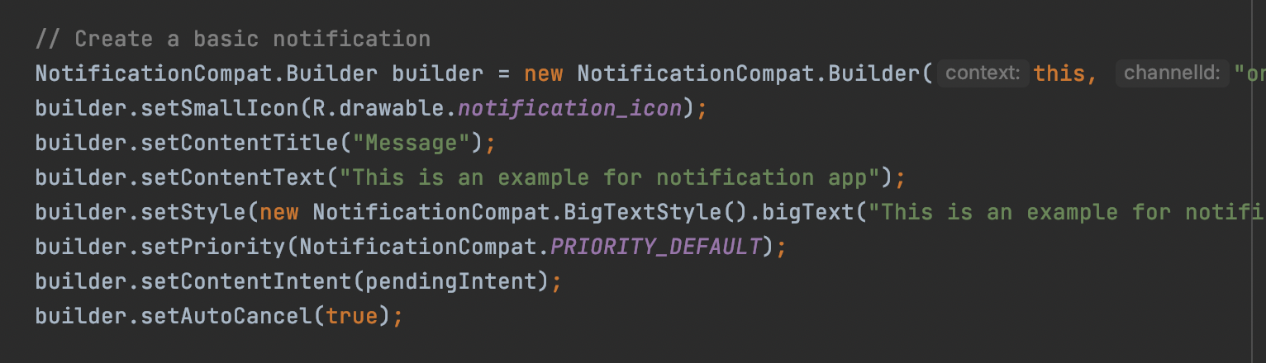

On Successful launch of the application:

Below is the home activity landing page

This notification API is lot more useful in the case of service workers in the web and also creating an powerful progressive web applications.

Users can also have an nice and user friendly UI with the notifications that will be sitting under quick settings.

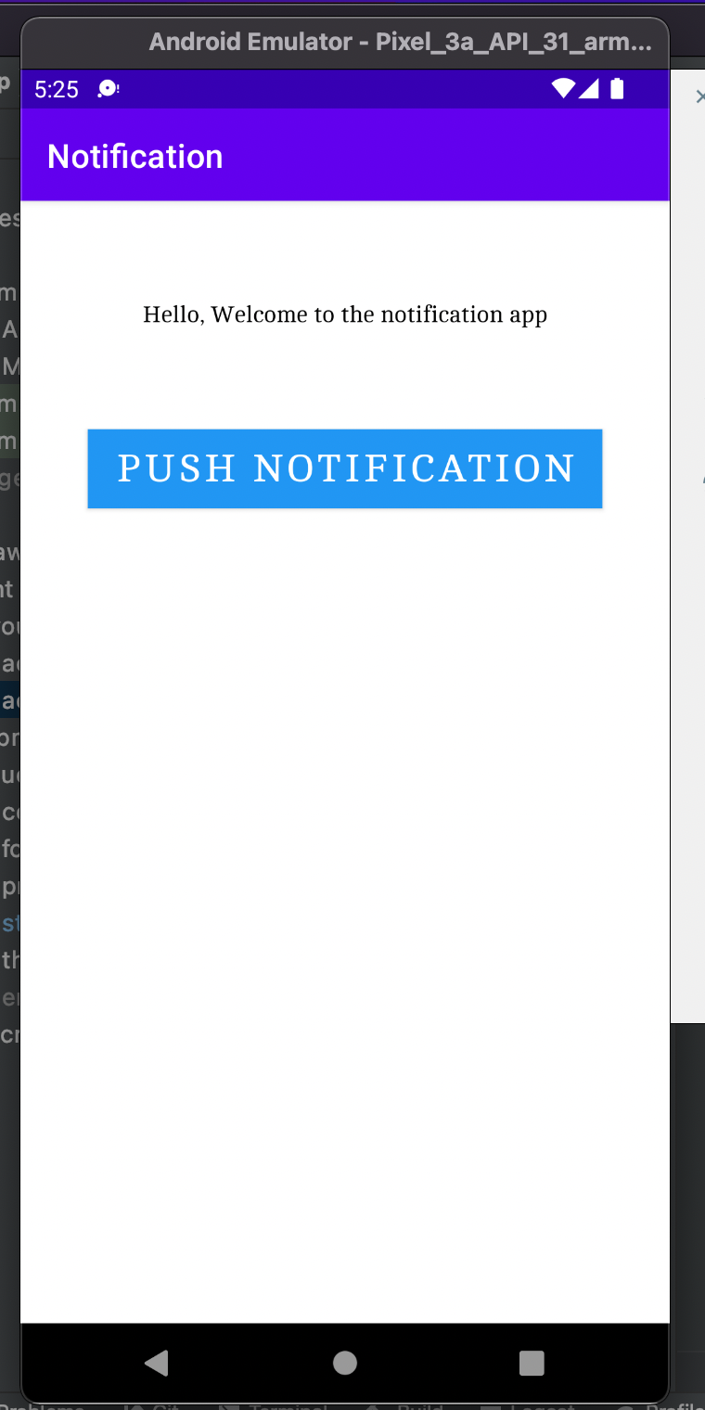

On click event listener of this button sendNotification method will be triggered and then notify method will be triggered

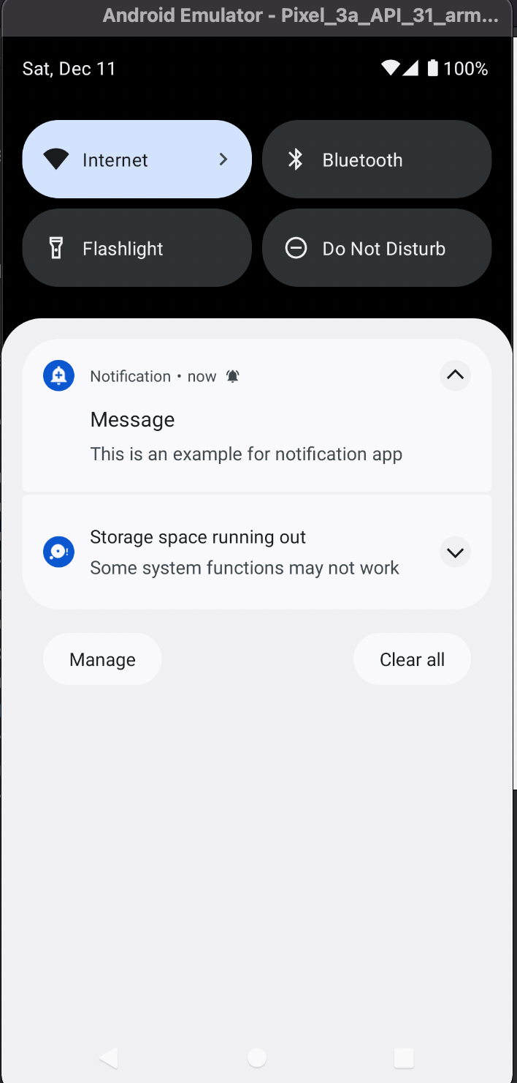

On Click of that notification below alert layout will be opened

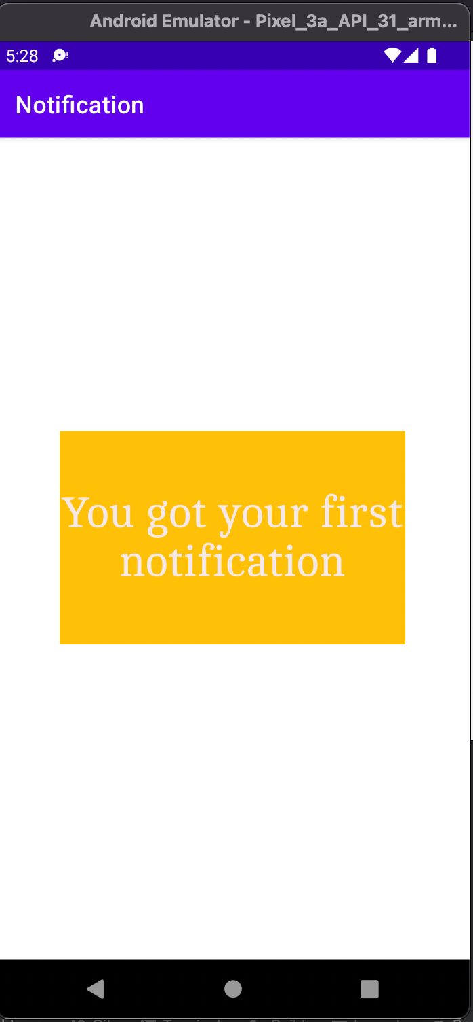

1. **Display and inserting event**

Creating an event with the following kotlin code

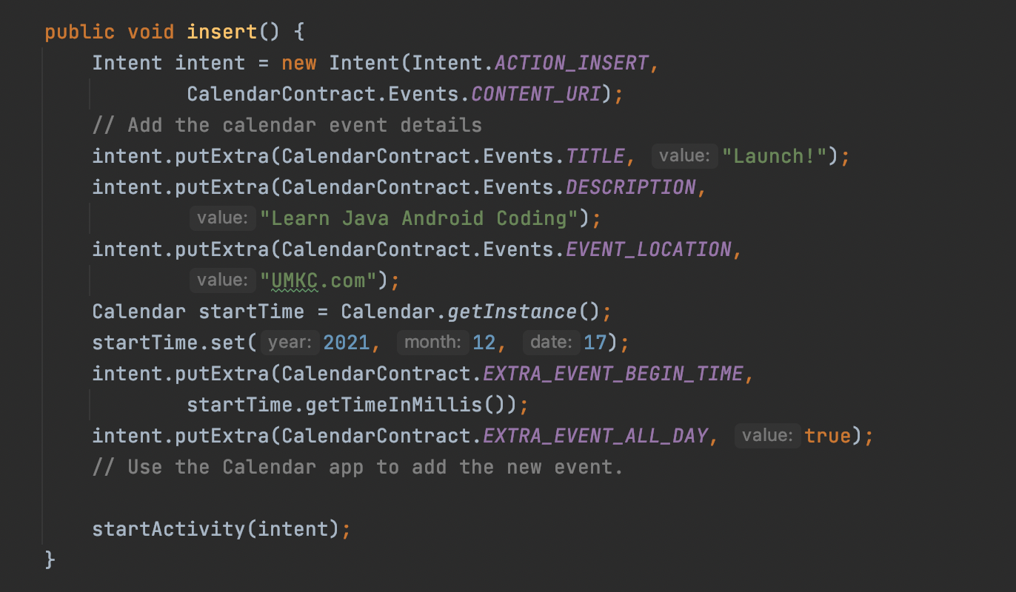

Home Activity:

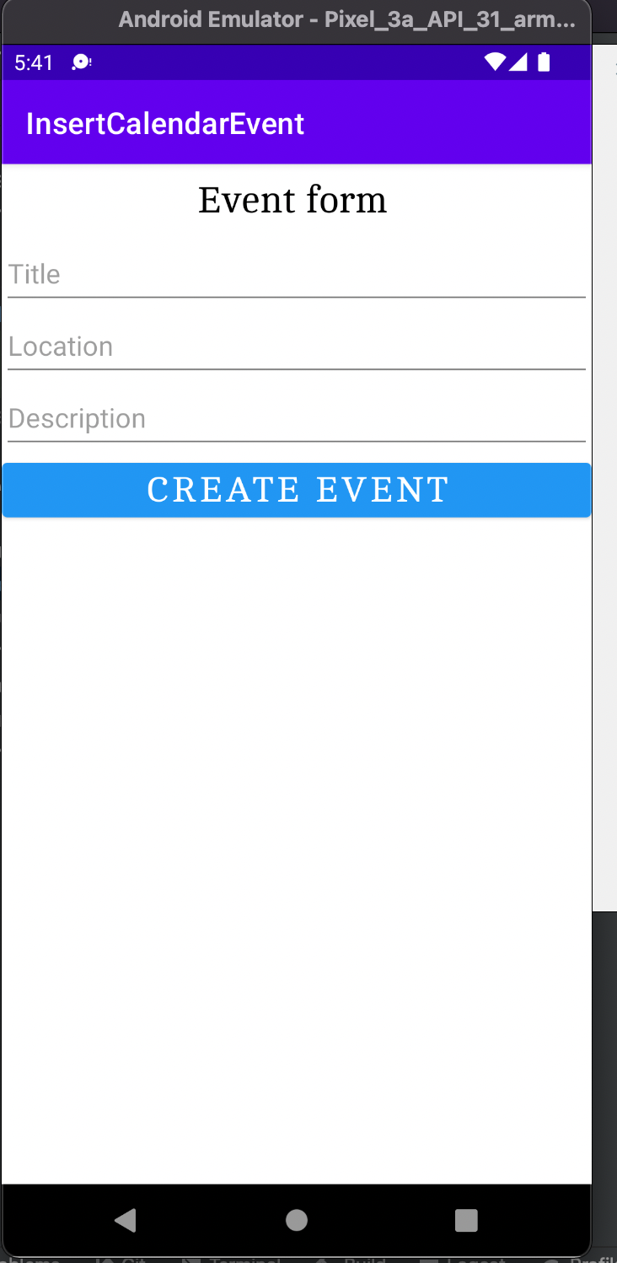

On Successful launch of the event, calendar application will be opened with sync from existing google calendars

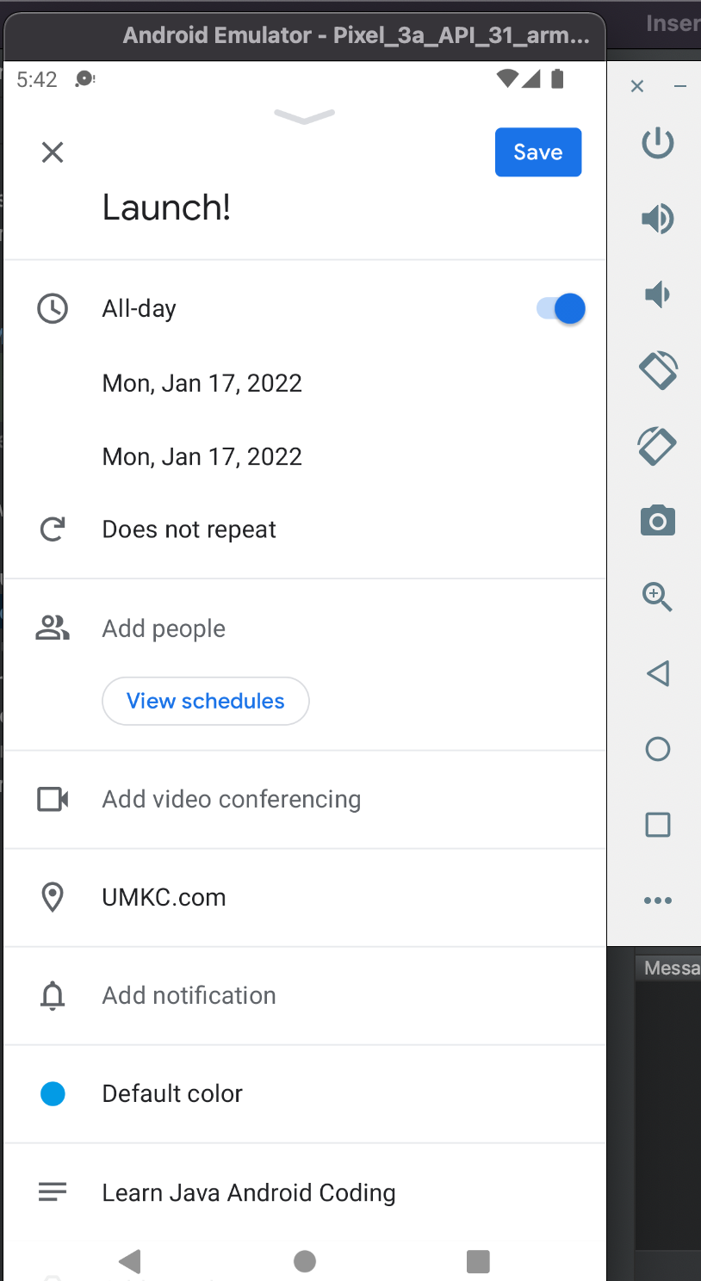

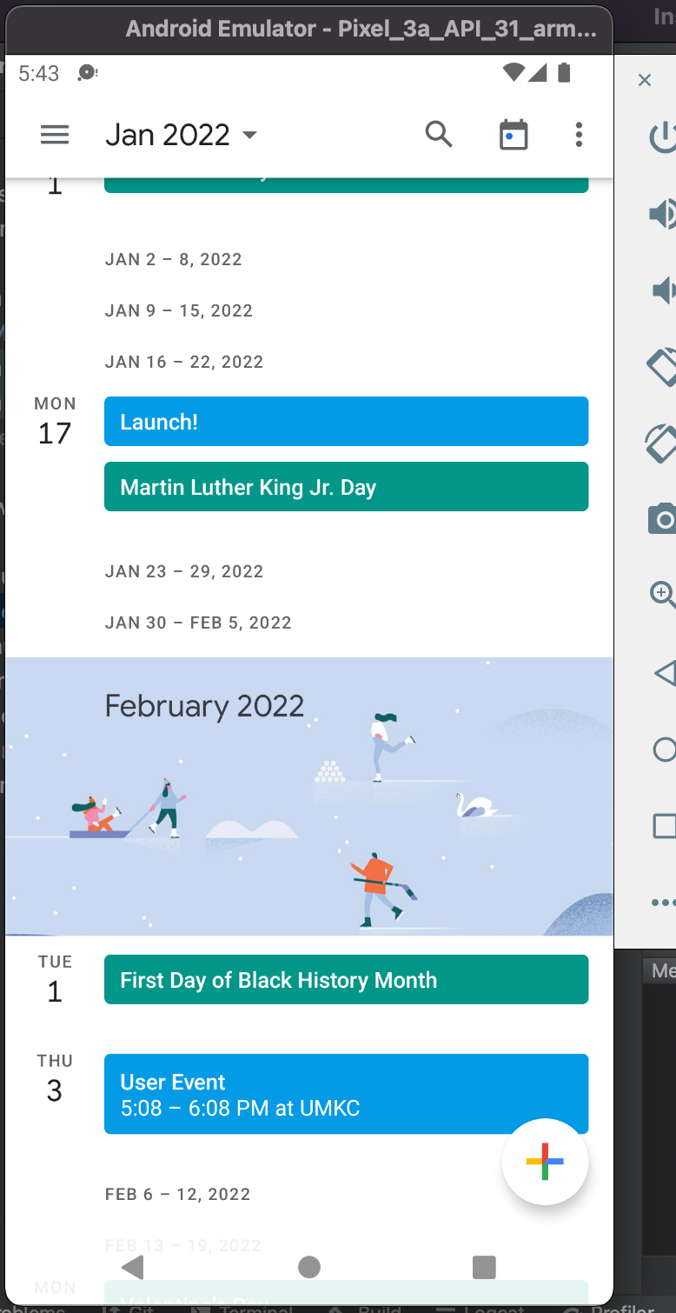

**Displaying the calendar event**

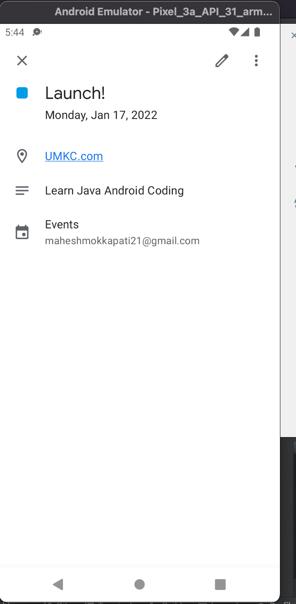

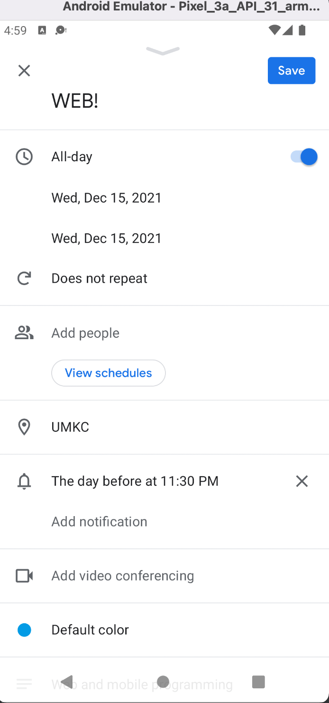

**Generating the APK:**

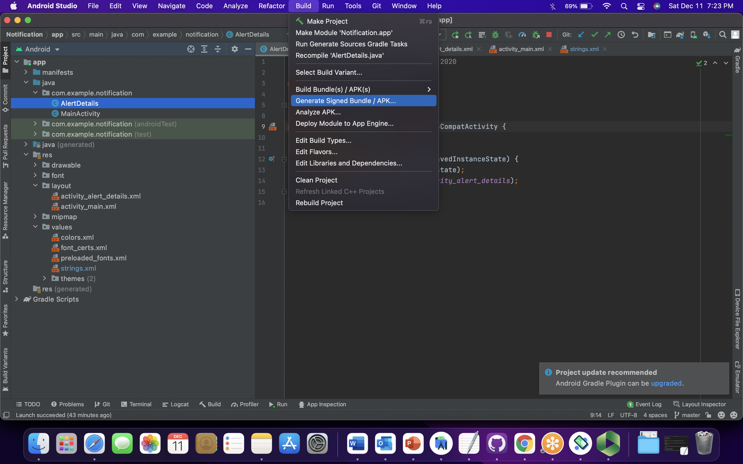

Under the build there is an option to generate the SDK/APK file. With this APK users can directly install the application into their devices with the compatibility settings turned off.

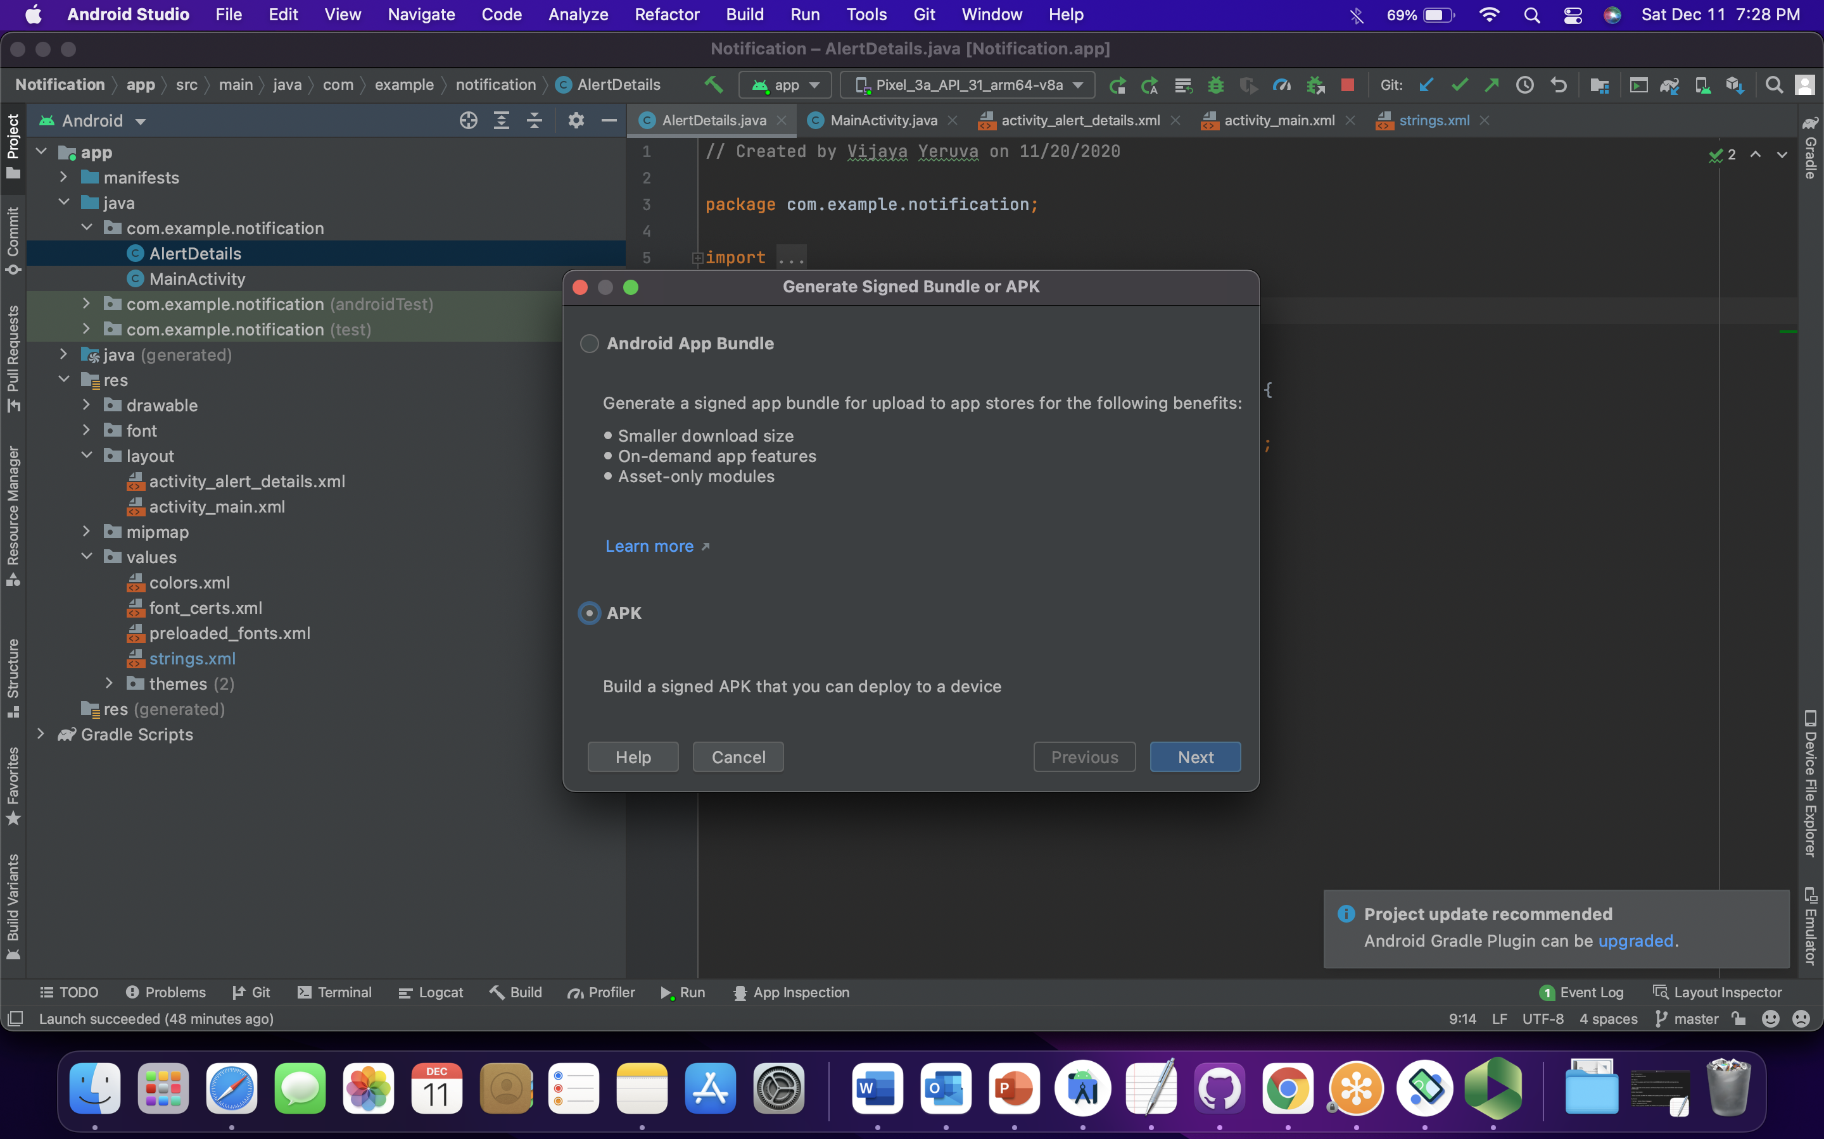

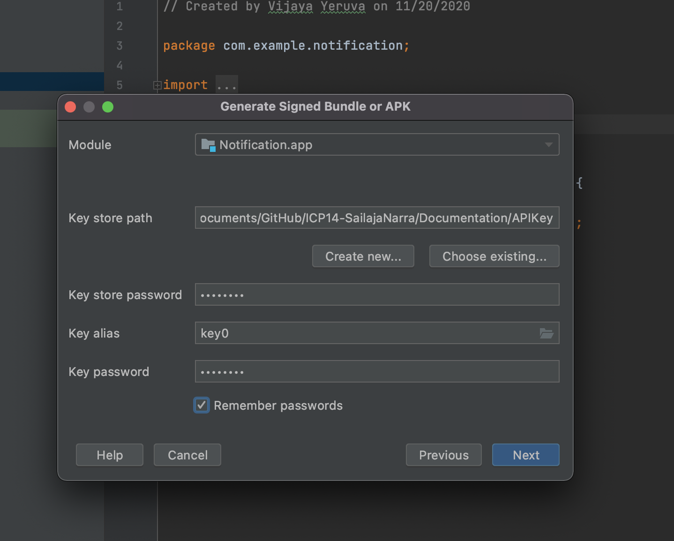

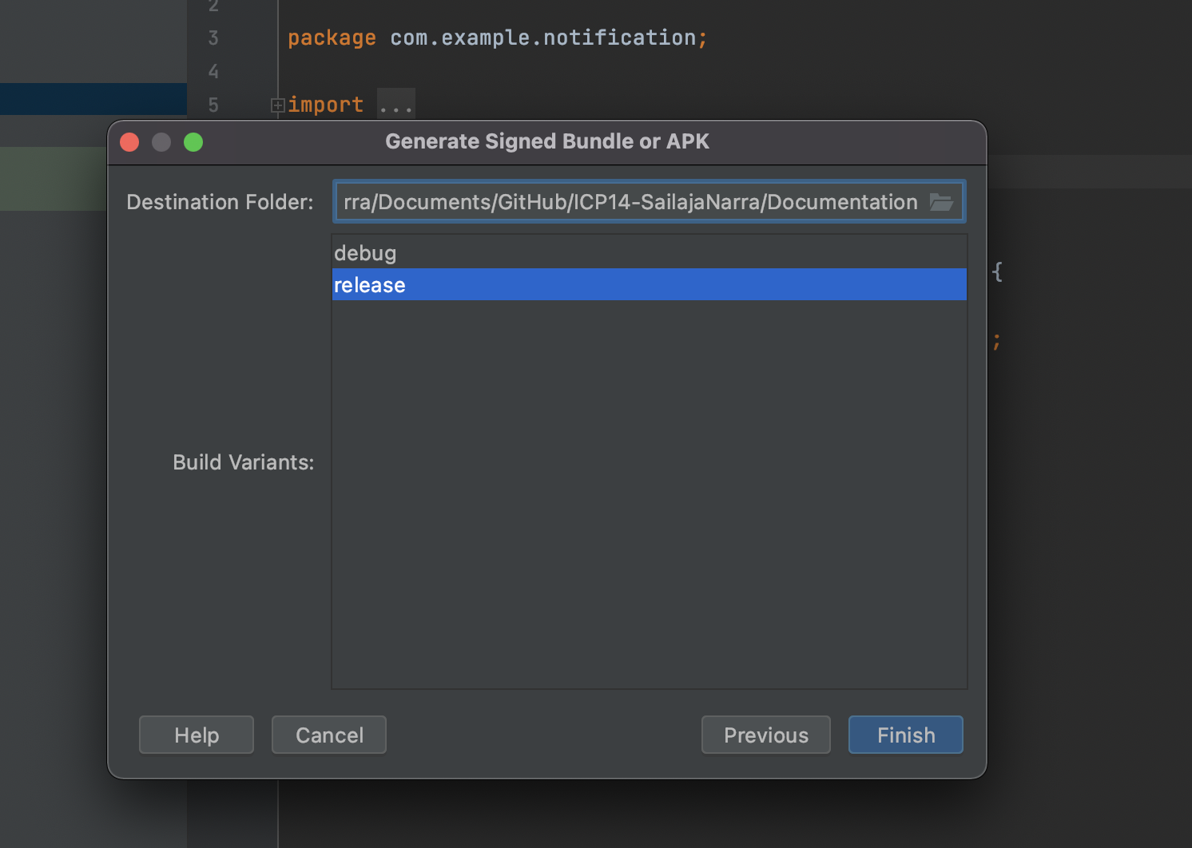

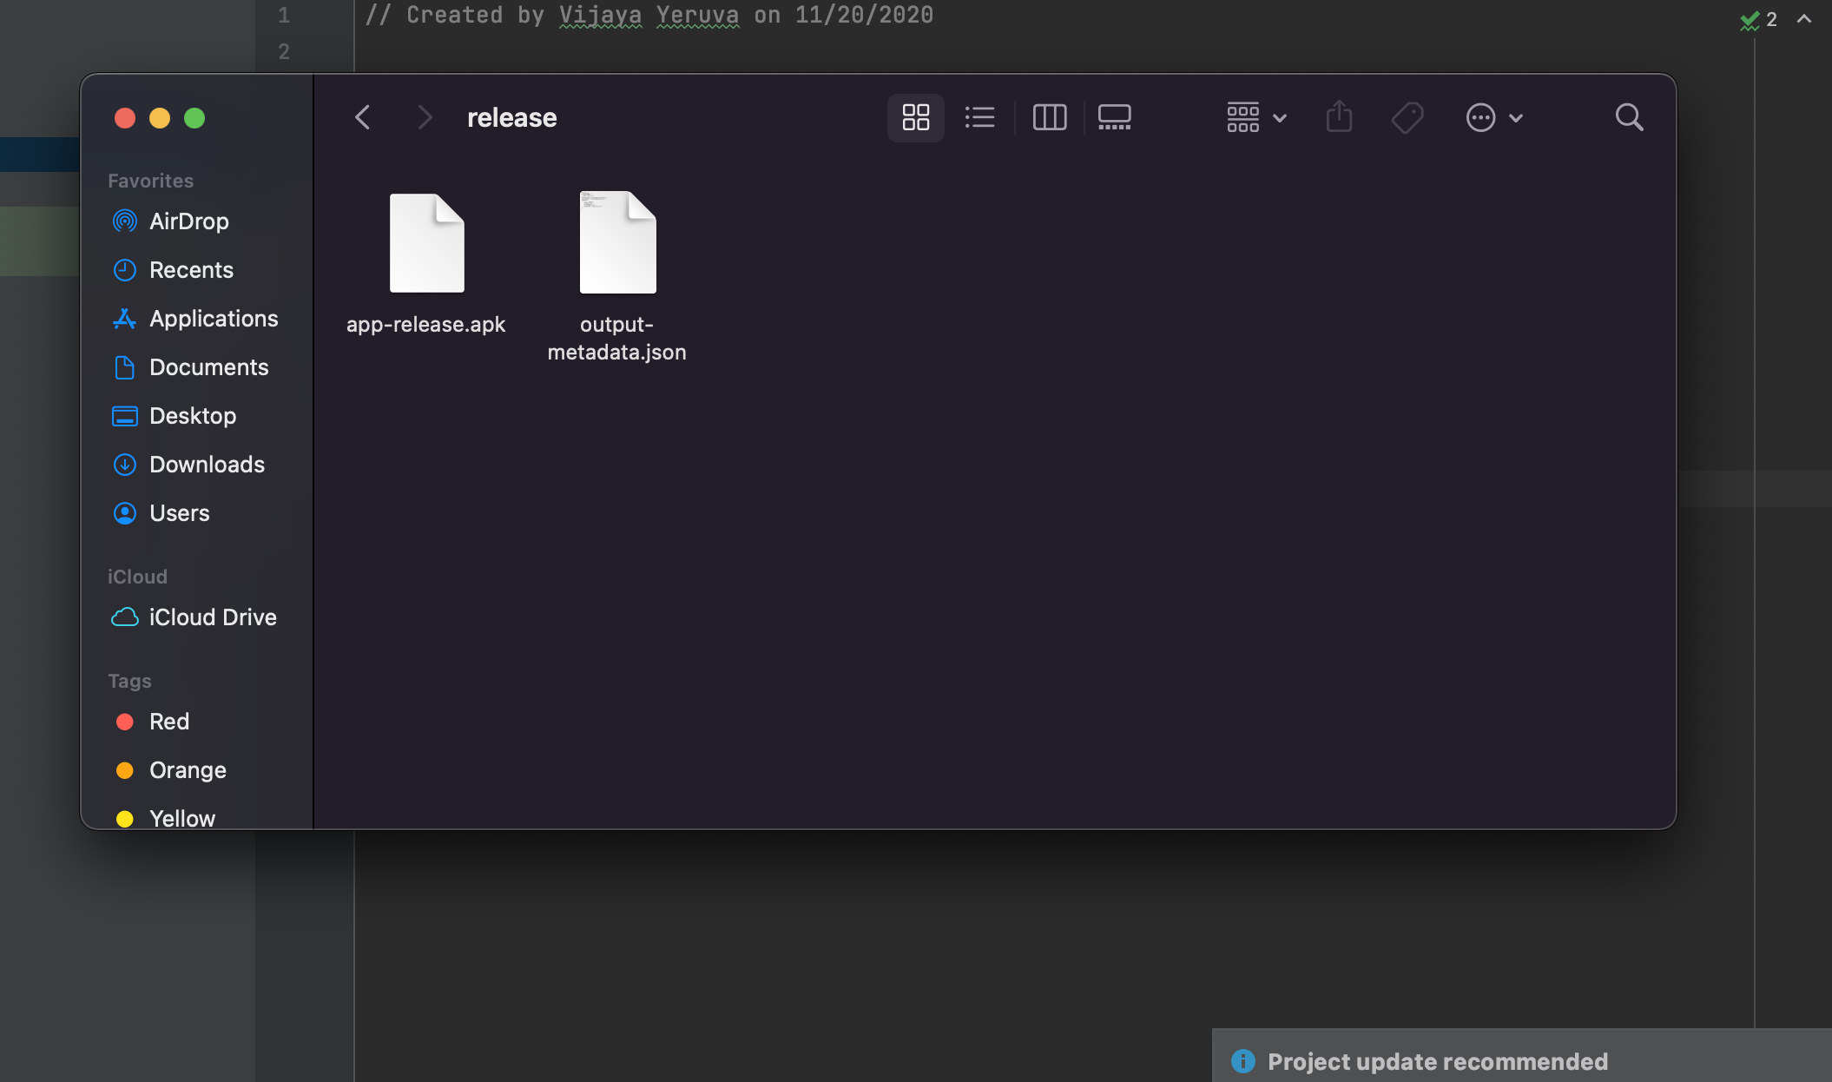

With this approach APK has been created successfully with the release version.